QUERY
create table EMP(
Empno int primary key not null,
Ename varchar(30),
Sal number(7,2
);

IMPORT DATA FROM EXCEL
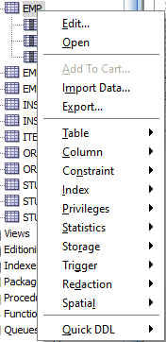

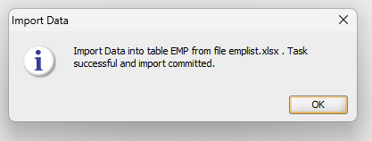

select * from EMP;

